PIZZA SALES SQL QUERIES

- KPI
- Total Revenue:
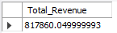

- Average Order Value:
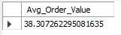

- Total Pizza sold
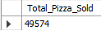

- Total order count
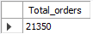

- Average Count of pizza per order
In this we will be using cast function which is use to convert one data type to another data type.
(10,2) – means 10 digits allowed and 2 digits after decimal point.
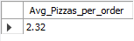

- Charts
- Daily trend for total orders
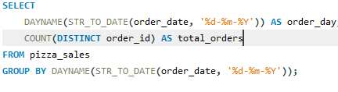
Done this bcz order_id was in text type so converted it into date type
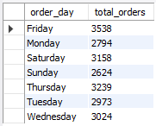

- Hourly trend for total orders
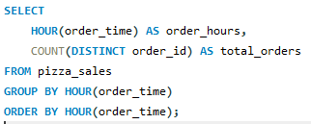
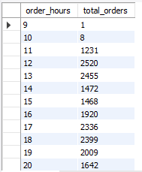

- Percentage of sales by pizza category
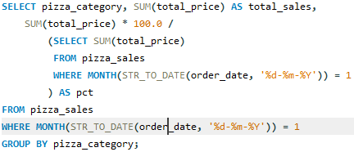

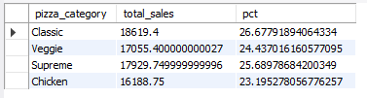

- Percentage of sales by pizza size
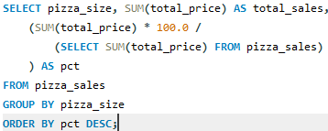
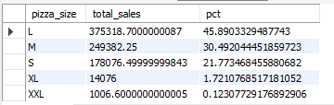

Quarter – Is a three month period so there are four quarters in a year. Q1 =jan,feb,march.

- Total pizza sold by pizza category
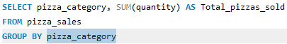
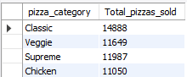

- Top 5 best sellers by Total pizza sold
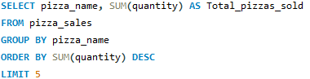
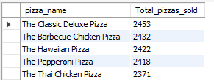

- Bottom 5
